|  |  |  |  |  |
| --- | --- | --- | --- | --- |
| Observation type | Number used | Initial errors (normalized by their uncertainties) | Final errors (normalized by their uncertainties) | Reduction (%) |
| SSH | 59964 | 596735.0238 | 262385.121 | 56.0298775 |
| U | 39147 | 75007.1037 | 56855.73699 | 24.1995302 |
| V | 39127 | 103900.6505 | 74879.6798 | 27.931462 |
| T | 357063 | 2644514.659 | 917743.9818 | 65.2963171 |
| S | 30635 | 1900493.573 | 497482.3029 | 73.8235209 |
| Total | 525936 | 5320651.01 | 1809346.82 | 65.9938827 |

Table S1: Table detailing assimilated variables, number of observations used, and reduction of error for the ROMS 4DVAR simulation.

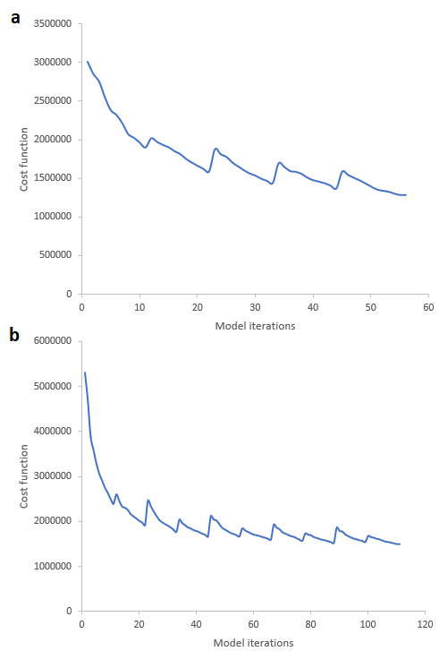

Figure S1: Graph showing the reduction across ROMS 4DVAR model iterations in the value of the cost function for the a) 2016 and b) 2017 model fits. The cost function assesses the degree of change between the model and its initial conditions as well as its success in minimizing differences between the model state and the observational dataset.

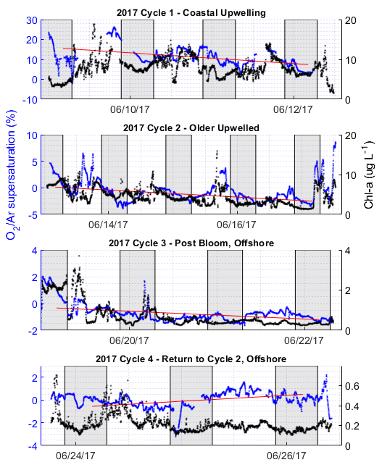

Figure S2: Raw ΔO2/Ar supersaturation (blue, primary y-axis) plotted with high-resolution Chl-*a* measurements from the 2017 expedition (black, secondary y-axis). The line of best fit for each cycle’s ΔO2/Ar data, derived from a linear regression against a subset of the cycle data beginning and ending at the same local time of day, is shown in red. Shaded sections of background indicate nighttime periods.